Ideation Phase
Brainstorm & Idea Prioritization Template
Date | 19 February2026
Team ID | LTVIP2026TMIDS24568
Project Name | Online Payments Fraud Detection using  Machine Learning
Maximum Marks | 4 Marks
Brainstorm & Idea Prioritization Template:
Brainstorming provides a free and open environment that encourages everyone within a team to participate in the creative thinking process that leads to problem solving. Prioritizing volume over value, out-of-the-box ideas are welcome and built upon, and all participants are encouraged to collaborate, helping each other develop a rich amount of creative solutions.
Use this template in your own brainstorming sessions so your team can unleash their imagination and start shaping concepts even if you're not sitting in the same room. Reference: https://www.mural.co/templates/brainstorm-and-idea-prioritization
Step-1: Team Gathering, Collaboration and Select the Problem Statement Team Gathering
The team members gathered to discuss issues related to online financial transactions and cyber fraud. Each member shared their thoughts about increasing digital payments and fraud risks in banking and UPI systems.
Team Members:
1.Balla Bhanu Akash
2.Kokkiligadda Jagadeesh
3.Koppineti Yuva Navya Srilatha
4.Karri Krishna Kumari
Collaboration Process
Discussion of Current Issues:
The team discussed problems such as:
- Increasing online payment fraud cases
- Unauthorized transactions
- Phishing and identity theft
- Financial losses to users
- Lack of real-time fraud detection
Sharing Individual Ideas:
Each member proposed ideas such as:
- Detect fraud using transaction amount patterns
- Analyze transaction type and balance changes
- Use machine learning algorithms
- Build real-time fraud monitoring system
- Create web app for fraud prediction
Evaluation of Ideas
The team selected the idea based on:
- Real-world importance
- Availability of dataset
- Practical implementation using ML
- Social and financial impact
Problem Statement
With the rapid growth of digital transactions, online payment fraud has become a serious issue. Fraudulent transactions cause financial loss to individuals and banks. Traditional rulebased systems are not sufficient to detect complex fraud patterns.
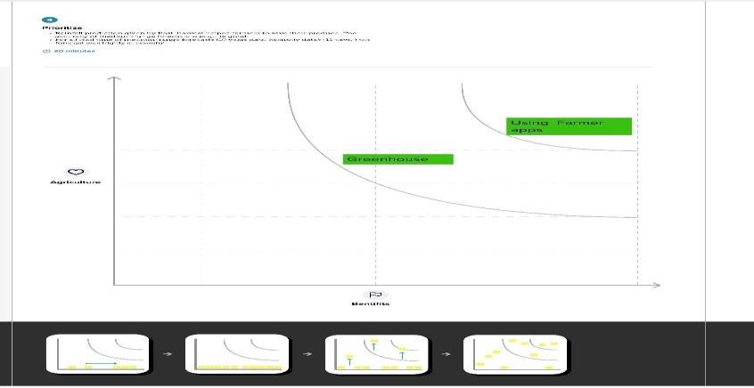
This project aims to build a machine learning model that analyzes transaction features such as amount, balance, and transaction type to detect fraudulent transactions in real time. The system helps financial institutions reduce fraud risk and ensure secure online payment systems.
Step-2: Brainstorm, Idea Listing and Grouping
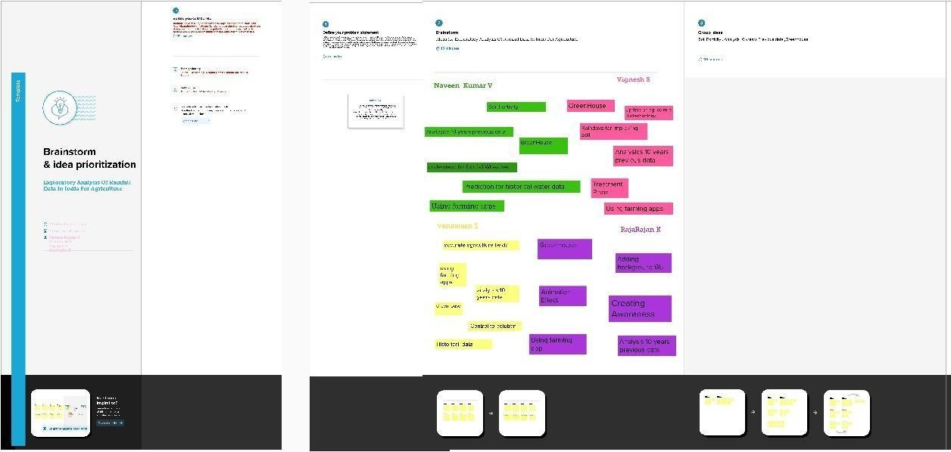
Step-3: Idea Prioritization

